**Project 5**

**Extra Credit: Server side Script for Automatic Table Creation**

This project uses the Wamp servers, and the installation process was exactly as in the posted documentation, and required no additional configurations.

In order to use the server, files must be placed in the www folder in the Wamp64 folder.

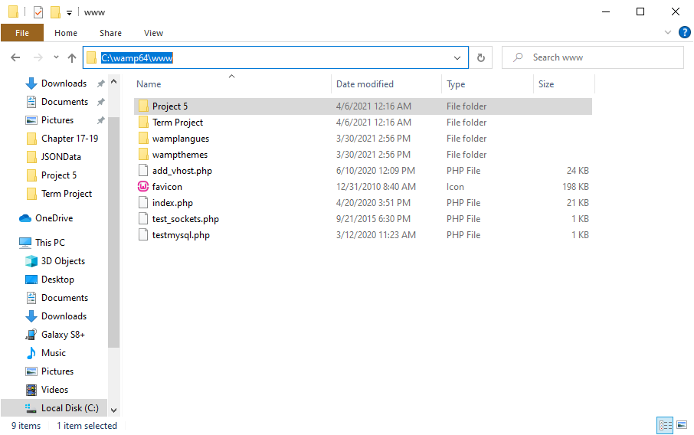

In order to have the server display the pages, you need to use “localhost” followed by the path to the html or php documents, for this project “<http://localhost/Project%205/>”

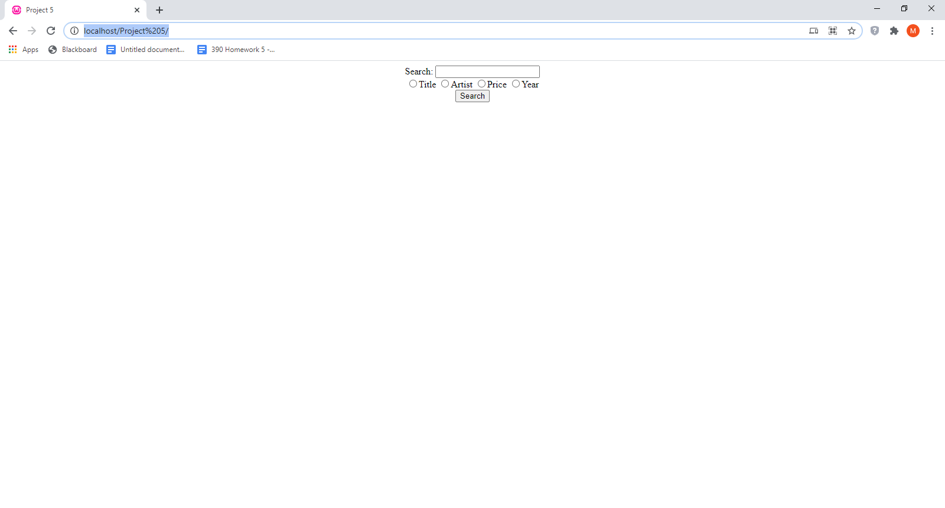

Path highlighted

For the server side, the database first needed to be created. This was easily done by using the Wamp server interface, myphpadmin.

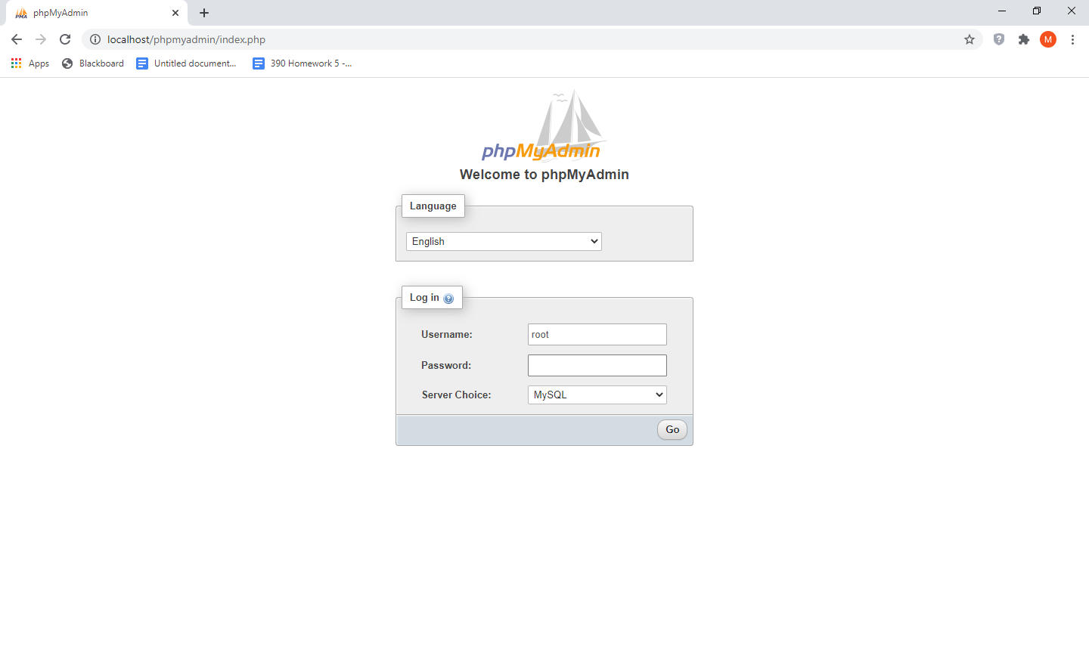

Log in

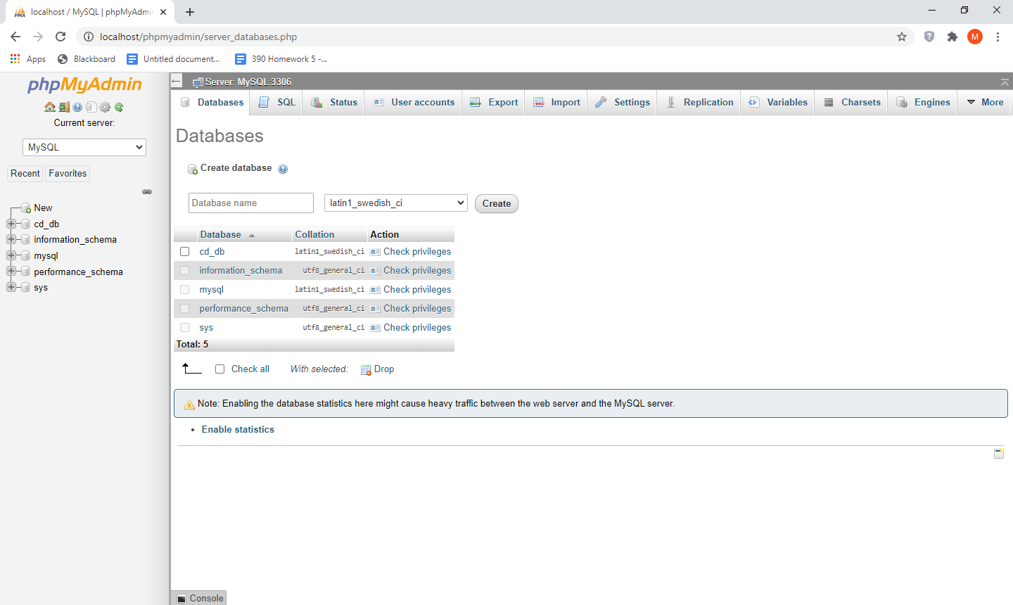

Navigate to the database tab and use the create database fields. I created a database named cd_db as you can see on the left side.

I used a php script to auto generate the table. It has 6 fields

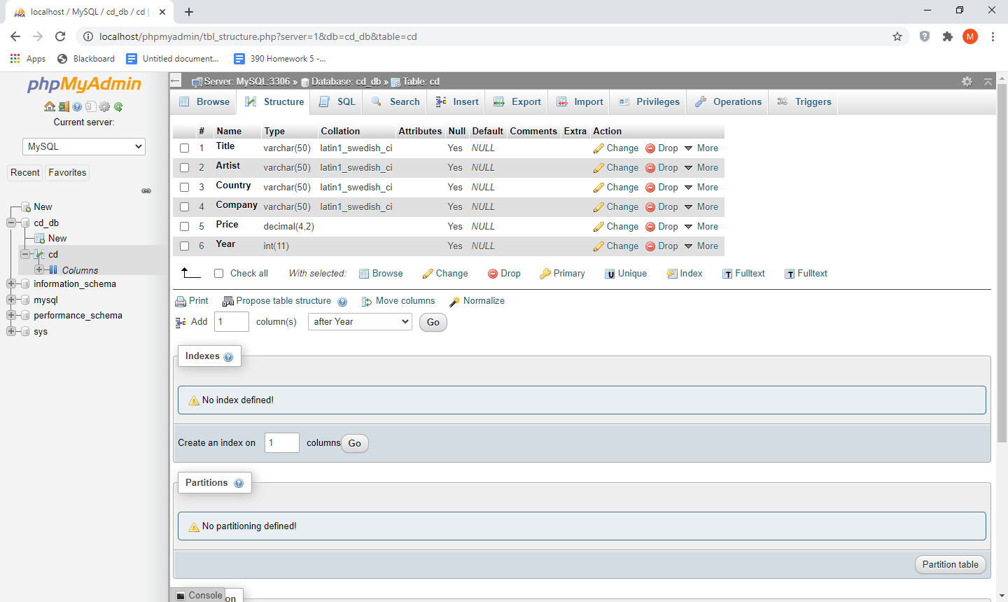

Table schema with column names and data types

For the searches on the site, it will find only exact matches (not cases sensitive). No sure how to query for partial matches.

**Screen shots**

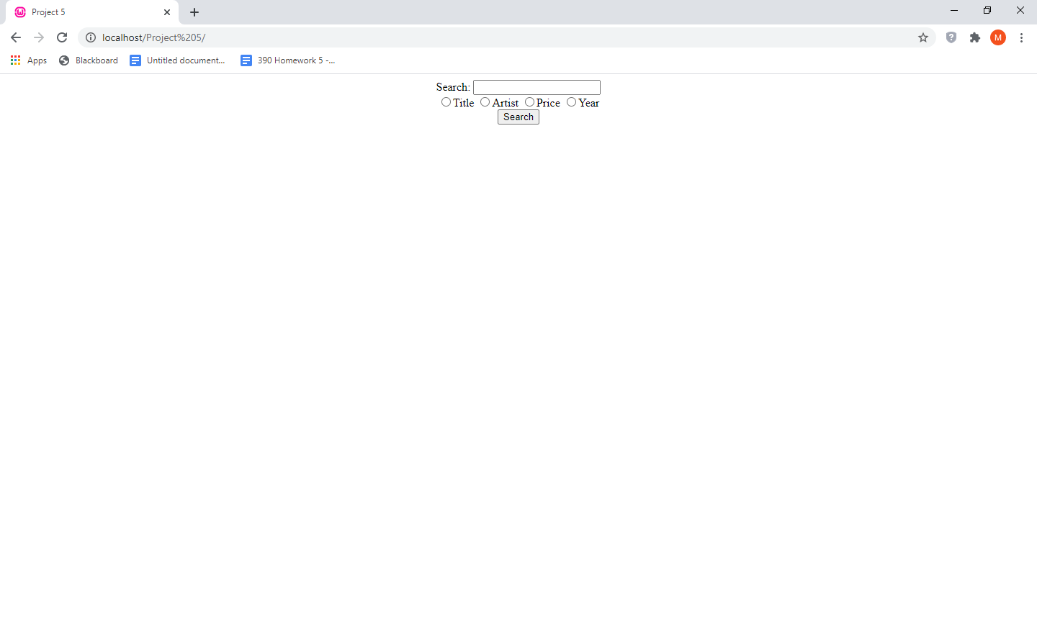

First access site

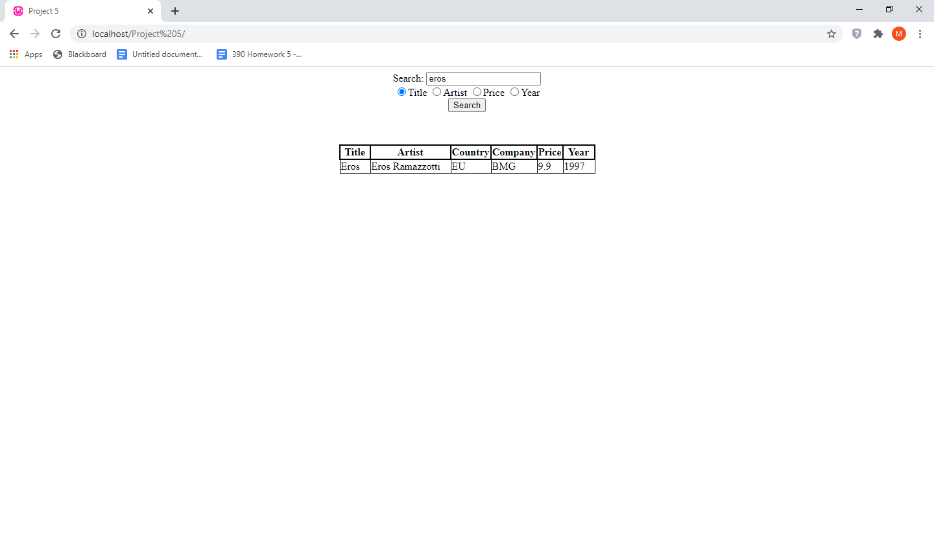

Title Search “eros”

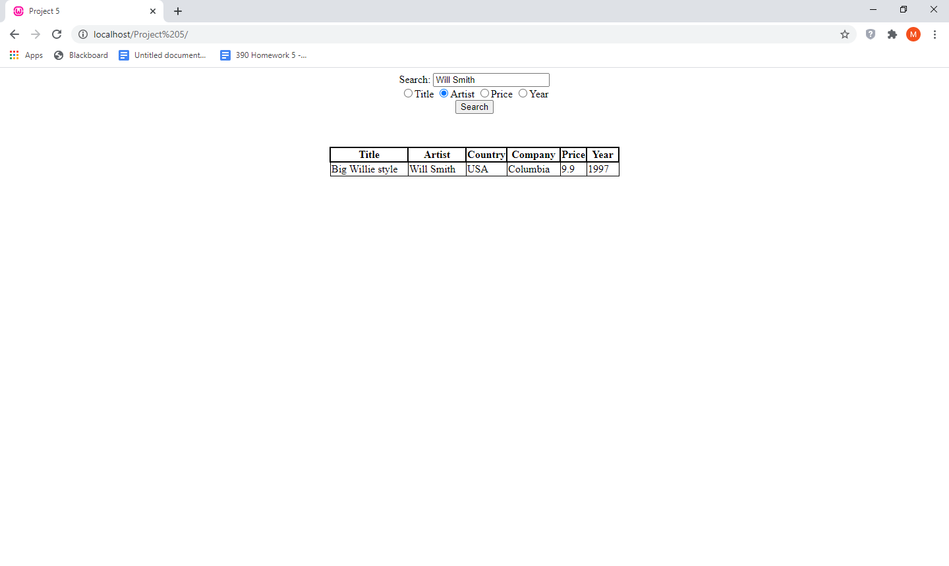

Artist search “Will Smith”

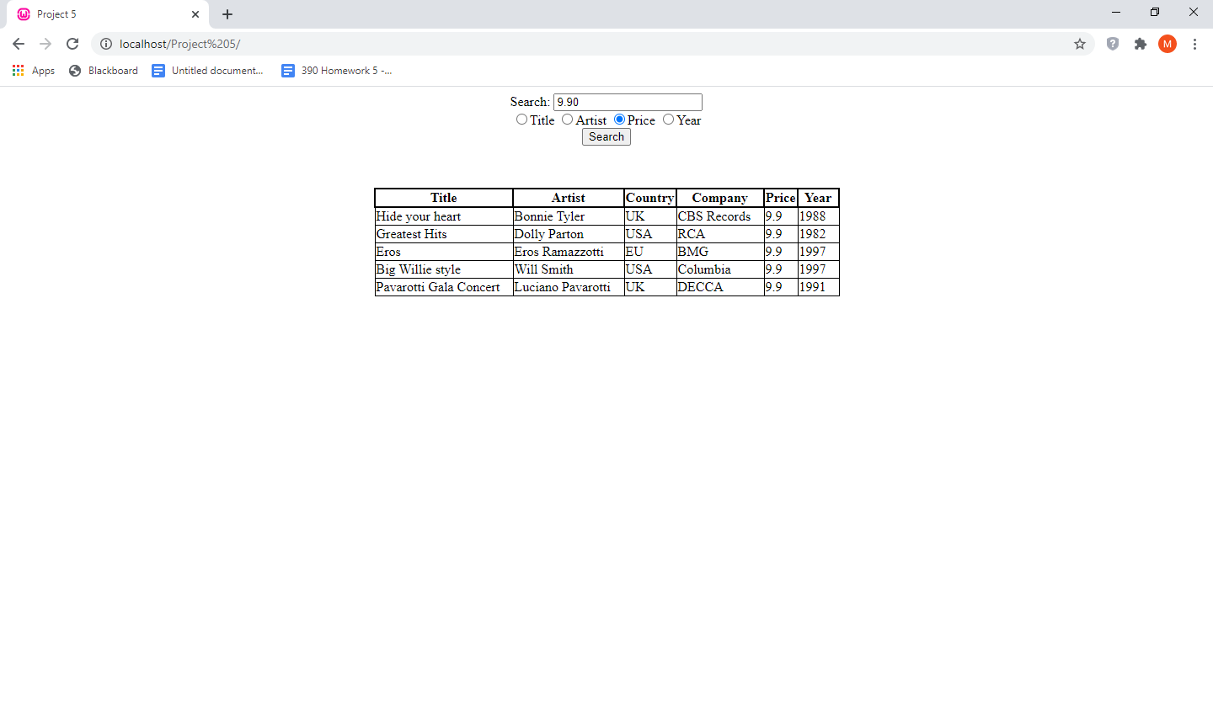

Price search “9.90”

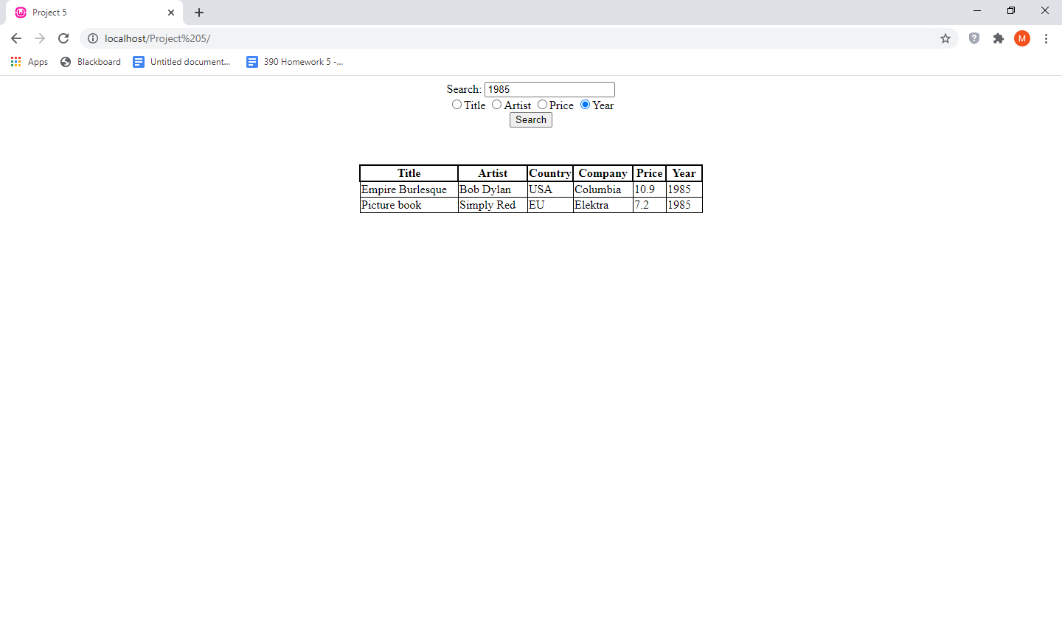

Year search “1985

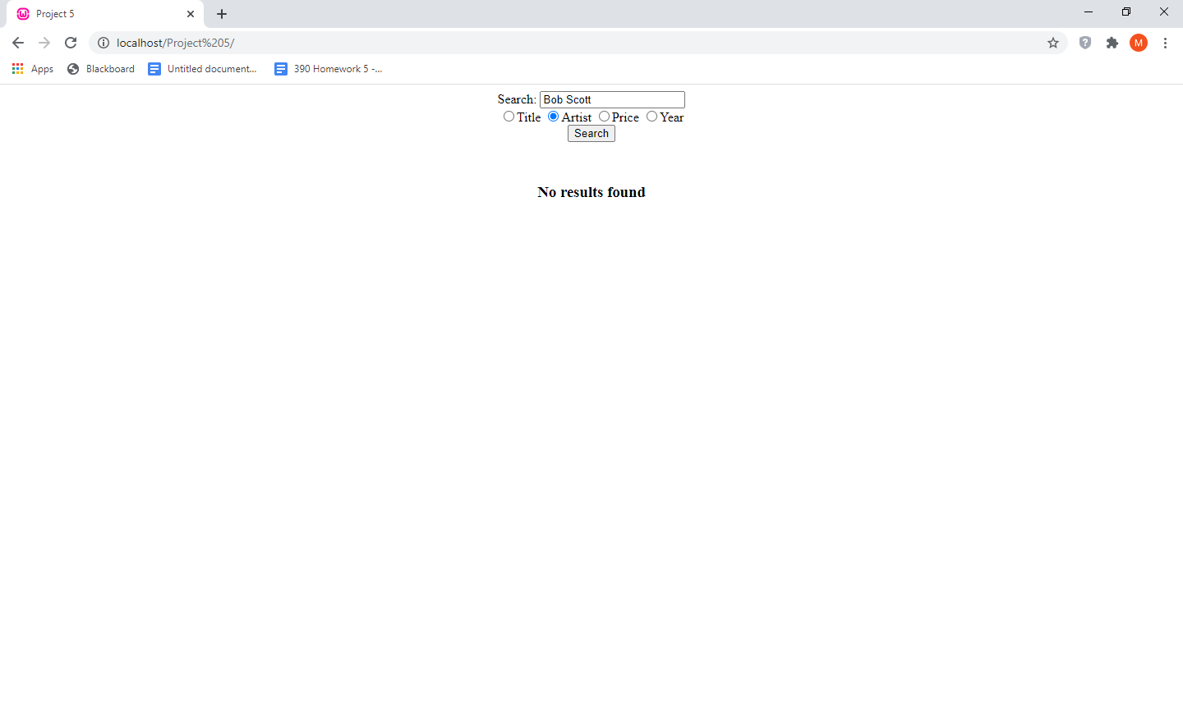

No result found (Artist search “Bob Scott”)

**Code:**

**DBloader.php (automated table creation)**

<?php

$xmlFile = simplexml_load_file("cd_catalog.xml") or die("Unable to open file");

$connection = new mysqli("localhost", "root", "", "CD_DB");

$result = $connection->query("Create table CD (Title varchar(50), Artist varchar(50),

Country varchar(50), Company varchar(50), Price decimal(4,2), Year int)");

foreach($xmlFile as $cd) {

$connection->query("Insert into CD Values ('$cd->TITLE', '$cd->ARTIST', '$cd->COUNTRY', '$cd->COMPANY', $cd->PRICE, $cd->YEAR)");

}

$connection->close();

echo "Done " . time();

?>

**Search.php**

<?php

$connection = new mysqli("localhost", "root", "", "CD_DB");

if($connection->connect_error) {

die("connection failed");

}

$query_string = "Select * from CD where " . $_GET['type'] . "='" . $_GET['search'] . "'";

$results = $connection->query($query_string);

if($results->num_rows > 0){

$first = 1;

echo '{"CD":[';

while($row = $results->fetch_assoc()) {

if($first == 0)

echo ",";

echo '{"TITLE":"' . $row['Title'] . '",';

echo '"ARTIST":"' . $row['Artist'] . '",';

echo '"COUNTRY":"' . $row['Country'] . '",';

echo '"COMPANY":"' . $row['Company'] . '",';

echo '"PRICE":' . $row['Price'] . ',';

echo '"YEAR":' . $row['Year'] . '}';

$first = 0;

}

echo "]}";

}

else {

echo '{"CD":[]}';

}

$connection->close();

?>

**Index.html**

<?xml version="1.0" encoding="UTF-8"?>

<!DOCTYPE html PUBLIC "-//W3C//DTD XHTML 1.1/EN"

"http://www.w3.org/TR/xhtml11/DTD/xhtml11.dtd">

<html xmlns="http://www.w3.org/1999/xhtml">

<head>

<title>Project 5</title>

<link type="text/css" href="style.css" rel="stylesheet" />

<script type="text/javascript" src="script.js"></script>

</head>

<body>

<div>

<center>

<label for="search">Search:</label>

<input type="text" id="search" name="search" /><br />

<input type="radio" id="name" name="type" value="Title" />

<label>Title</label>

<input type="radio" id="artist" name="type" value="Artist" />

<label>Artist</label>

<input type="radio" id="price" name="type" value="Price" />

<label>Price</label>

<input type="radio" id="year" name="type" value="Year" />

<label>Year</label><br />

<button id="searchbtn" onclick="search()">Search</button>

</center>

</div>

<center><div id="results"></div></center>

</body>

</html>

**style.css**

#results table {

border-collapse: collapse;

}

#results table th {

border: 2px solid black;

}

#results table td {

border: 1px solid black;

padding-right: 15px;

}

**script.js**

function search() {

var parsed_query;

var search_type = document.querySelector('input[name="type"]:checked').value;

var search = document.getElementById("search").value;

var php = new XMLHttpRequest();

php.onreadystatechange = function () {

if(this.readyState == 4 && this.status == 200) {

parsed_query = this.responseText;

console.log(parsed_query);

parsed_query = JSON.parse(parsed_query);

print_results(parsed_query);

}

};

php.open("Get", "search.php?search="+search+"&type="+search_type, true);

php.send();

}

function print_results(query) {

var results = document.getElementById("results");

var table = "<table class='data'>";

results.style.marginTop = "50px";

if(query.CD.length > 0){

table += "<tr><th>Title</th><th>Artist</th><th>Country</th><th>Company</th><th>Price</th><th>Year</th></tr>";

console.log(query.CD.length);

for(var i=0; i<query.CD.length; i++){

var cd = query.CD[i];

table +="<tr><td>" + cd.TITLE + "</td><td>" + cd.ARTIST + "</td><td>" + cd.COUNTRY + "</td><td>" +

cd.COMPANY + "</td><td>" + cd.PRICE + "</td><td>" + cd.YEAR + "</td></tr>";

}

table += "</table>";

results.innerHTML = table;

}

else {

results.innerHTML ="<h3>No results found</h4>";

}

results.classList.add("data");

}